**CODINGS**

**ANACONDA SPYDER PYTHON**

**# -*- coding: utf-8 -*-**

**"""**

**Created on Fri May 22 19:25:22 2020**

**@author: user**

**"""**

**# -*- coding: utf-8 -*-**

**"""**

**Created on Sun Mar 1 21:17:54 2020**

**@author: user**

**"""**

**import pandas as pd**

**mydataset = pd.read_csv('data.csv')**

**import matplotlib.pyplot as plt**

**import seaborn as sns**

**import numpy as np**

**mydataset.shape**

**mydataset.head(7)**

**# FINDING A NULL VALUES**

**mydataset.isna().sum()**

**#DROP THE COLUMN WITH ALL MISSING VALUES**

**mydataset = mydataset.dropna(axis=1)**

**#GET the new count of the number of rows and columns**

**mydataset.shape**

**mydataset.describe()**

**mydataset.isnull().values.any()**

**#GET THE COUNT OF THE NUMBER OF MALIGANT (M) OR BENIGN (B) CELLS**

**mydataset['diagnosis'].value_counts()**

**print("Cancer data set dimensions : {}".format(mydataset.shape))**

**#Understand the target varibale further**

**mydataset["diagnosis"].value_counts()#Visualize dataset using Histograms**

**#A histogram is a plot that lets you discover, and show, the underlying frequency distribution**

**import matplotlib.pyplot as plt**

**num_bins = 10**

**mydataset.hist(bins=num_bins, figsize=(20,15))**

**plt.show()**

**#VISUALIZE THE COUNT**

**sns.countplot(mydataset['diagnosis'], label='count')**

**#Look at the (dtype) data types to see which columns need to be encoded**

**mydataset.dtypes**

**#ENCODE THE CATEGORICAL DATA VALUES**

**from sklearn.preprocessing import LabelEncoder**

**labelencoder_Y = LabelEncoder()**

**mydataset.iloc[:,1] = labelencoder_Y.fit_transform(mydataset.iloc[:,1].values)**

**mydataset.iloc[:,1]**

**# create apair plot**

**sns.pairplot(mydataset.iloc[:,1:6])# 6 is nothing but index**

**sns.pairplot(mydataset.iloc[:,1:6], hue='diagnosis')**

**#print the first 5 rows of the new data**

**mydataset.head(5)**

**#get the correlation of the columns**

**mydataset.iloc[:,1:12].corr()**

**"""**

**#IF WE WANT IN COLOR HEATMAP WE CAN GO FOR IT#**

**from matplotlib.colors import ListedColormap**

**plt.figure(figsize=(8, 8))**

**sns.heatmap(mydataset.iloc[:,1:12].corr(), cbar=True, annot=False, fmt='.0%',**

**cmap=ListedColormap(['#C71585', '#DB7093', '#FF00FF', '#FF69B4', '#FFB6C1', '#FFC0CB']),**

**)**

**plt.show()**

**"""**

**#visualize the corelation**

**plt.figure(figsize=(10,10))**

**sns.heatmap(mydataset.iloc[:,1:12].corr(), annot=True, fmt='.0%')**

**#box plot to check outlier in each category**

**#define function can be call later**

**def boxPlot(dff):**

**d=dff.drop(columns=['diagnosis'])**

**for column in d:**

**plt.figure(figsize=(5,2))**

**sns.boxplot(x=column,data=d,palette="colorblind")**

**boxPlot(mydataset)**

**#Box plot for radius mean**

**#We can use box plots to identify outliers in a dataset.**

**#These can be rare occurrence or errors. Sometimes these can provide insight.**

**melted_data = pd.melt(mydataset,id_vars = "diagnosis",value_vars = ['radius_mean'])**

**plt.figure(figsize = (15,10))**

**sns.boxplot(x = "variable", y = "value", hue="diagnosis",data= melted_data)**

**plt.show()**

**#From the box plot we can see the range of the radius mean values for bening and malignant tumors.**

**#We can also clearly see the outliers in the above visualizations (marked points lying outside the range).**

**#Box plot for area mean**

**melted_data = pd.melt(mydataset,id_vars = "diagnosis",value_vars = ['area_mean'])**

**plt.figure(figsize = (15,10))**

**sns.boxplot(x = "variable", y = "value", hue="diagnosis",data= melted_data)**

**plt.show()**

**#INFERENCE: From the graph, we can say that after a certain threshold for the values of the given features,**

**# we can classify the tumor as malignant (but we also see outliers, so maybe not with a 100% certainty**

**#every time, there could be some false positives).**

**#Box plot for perimeter mean**

**melted_data = pd.melt(mydataset,id_vars = "diagnosis",value_vars = ['perimeter_mean'])**

**plt.figure(figsize = (15,10))**

**sns.boxplot(x = "variable", y = "value", hue="diagnosis",data= melted_data)**

**plt.show()**

**#split the data set into independent (X) and dependent (y) data sets**

**X=mydataset.iloc[:,2:31].values**

**Y=mydataset.iloc[:,1].values**

**#split the dataset into 75% training and 25% testing**

**from sklearn.model_selection import train_test_split**

**X_train, X_test, Y_train, Y_test = train_test_split(X, Y, test_size =0.25, random_state =0)**

**#scale the data(feature scaling)**

**from sklearn.preprocessing import StandardScaler**

**sc = StandardScaler()**

**X_train = sc.fit_transform(X_train)**

**X_test = sc.fit_transform(X_test)**

**X_train**

**Y_train**

**X_test**

**Y_test**

**from sklearn.metrics import accuracy_score**

**from sklearn.metrics import f1_score**

**#Model Evaluation**

**#1 LOGISTIC REGRESSION**

**from sklearn.linear_model import LogisticRegression**

**classifier = LogisticRegression(random_state = 0)**

**#Train the model**

**classifier.fit(X_train, Y_train)**

**#Test it using the test dataset**

**Y_pred1 = classifier.predict(X_test)**

**import seaborn as sns**

**def seaborn_plot_cm(cm, model_name):**

**sns.heatmap(cm, annot = True, fmt = '.2f',**

**xticklabels = ['Benign', 'Malignant'], yticklabels = ['Benign', 'Malignant'])**

**plt.ylabel('True Class')**

**plt.xlabel('Predicted Class')**

**plt.title(model_name)**

**plt.savefig(model_name)**

**from sklearn.metrics import accuracy_score, confusion_matrix, classification_report**

**def print_classification_report(classifier_name, Y_pred1, Y_test):**

**print(classifier_name + ' Accuracy: {:.3f}'.format(accuracy_score(Y_test,**

**Y_pred1)))**

**cm = confusion_matrix(Y_test, Y_pred1)**

**print(classification_report(Y_test, Y_pred1))**

**seaborn_plot_cm(cm, classifier_name)**

**print_classification_report('Logistic Regression', Y_pred1, Y_test)**

**cm = confusion_matrix(Y_test, Y_pred1)**

**tp = cm[0,0]**

**fp = cm[0,1]**

**fn = cm[1,0]**

**tn = cm[1,1]**

**print ('True Positive >', tp)**

**print ('False Positive >', fp)**

**print ('False Negetive >', fn)**

**print ('True Negetive >', tn)**

**print ('Final prediction >', round((tp+tn)/(len(Y_pred1))*100,2))**

**# 1.2 roc curve**

**from sklearn.metrics import roc_curve, roc_auc_score**

**from matplotlib import pyplot as plt**

**fpr, tpr, _ = roc_curve(Y_test, Y_pred1)**

**print('ROC AUC: %.3f' % roc_auc_score( y_true=Y_test, y_score=Y_pred1))**

**plt.clf()**

**plt.plot(fpr, tpr)**

**plt.xlabel('FPR')**

**plt.ylabel('TPR')**

**plt.title('ROC curve')**

**plt.show()**

**#2 RANDOM FOREST**

**from sklearn.ensemble import RandomForestClassifier**

**rd_forest_classifier = RandomForestClassifier(n_estimators = 10,**

**criterion = 'entropy',**

**random_state = 0)**

**rd_forest_classifier.fit(X_train, Y_train)**

**rd_forest_Y_pred = rd_forest_classifier.predict(X_test)**

**print_classification_report('Random Forest', rd_forest_Y_pred, Y_test)**

**#2.1 confusion matrix for random forest**

**cm = confusion_matrix(Y_test, rd_forest_Y_pred)**

**tp = cm[0,0]**

**fp = cm[0,1]**

**fn = cm[1,0]**

**tn = cm[1,1]**

**print ('True Positive >', tp)**

**print ('False Positive >', fp)**

**print ('False Negetive >', fn)**

**print ('True Negetive >', tn)**

**print ('Final prediction >', round((tp+tn)/(len(rd_forest_Y_pred))*100,2))**

**#2.2 ROC**

**fpr, tpr, _ = roc_curve(Y_test, rd_forest_Y_pred)**

**print('ROC AUC: %.3f' % roc_auc_score( y_true=Y_test, y_score=rd_forest_Y_pred))**

**plt.clf()**

**plt.plot(fpr, tpr)**

**plt.xlabel('FPR')**

**plt.ylabel('TPR')**

**plt.title('ROC curve')**

**plt.show()**

**#3 GAUSSIAN NAIVE BAYES**

**from sklearn.naive_bayes import GaussianNB**

**gbNB_classifier = GaussianNB()**

**gbNB_classifier.fit(X_train, Y_train)**

**gb_NB_Y_pred = gbNB_classifier.predict(X_test)**

**print_classification_report('Gaussian Naive Bayes', gb_NB_Y_pred, Y_test)**

**#3.1confusion matrix**

**cm = confusion_matrix(Y_test, gb_NB_Y_pred)**

**tp = cm[0,0]**

**fp = cm[0,1]**

**fn = cm[1,0]**

**tn = cm[1,1]**

**print ('True Positive >', tp)**

**print ('False Positive >', fp)**

**print ('False Negetive >', fn)**

**print ('True Negetive >', tn)**

**print ('Final prediction >', round((tp+tn)/(len(gb_NB_Y_pred))*100,2))**

**#3.2ROC FOR NAIVE BAYES**

**fpr, tpr, _ = roc_curve(Y_test, gb_NB_Y_pred)**

**print('ROC AUC: %.3f' % roc_auc_score( y_true=Y_test, y_score=gb_NB_Y_pred))**

**plt.clf()**

**plt.plot(fpr, tpr)**

**plt.xlabel('FPR')**

**plt.ylabel('TPR')**

**plt.title('ROC curve')**

**plt.show()**

**#4 DECISION TREE**

**from sklearn.tree import DecisionTreeClassifier**

**DT_classifier = DecisionTreeClassifier(criterion = 'entropy', random_state = 0)**

**DT_classifier.fit(X_train, Y_train)**

**DT_pred = DT_classifier.predict(X_test)**

**print_classification_report('Decision Tree', DT_pred, Y_test)**

**#4.1 confusion matrix**

**cm = confusion_matrix(Y_test, DT_pred)**

**tp = cm[0,0]**

**fp = cm[0,1]**

**fn = cm[1,0]**

**tn = cm[1,1]**

**print ('True Positive >', tp)**

**print ('False Positive >', fp)**

**print ('False Negetive >', fn)**

**print ('True Negetive >', tn)**

**print ('Final prediction >', round((tp+tn)/(len(DT_pred))*100,2))**

**#4.2 ROC FOR NAIVE BAYES**

**fpr, tpr, _ = roc_curve(Y_test, DT_pred)**

**print('ROC AUC: %.3f' % roc_auc_score( y_true=Y_test, y_score=DT_pred))**

**plt.clf()**

**plt.plot(fpr, tpr)**

**plt.xlabel('FPR')**

**plt.ylabel('TPR')**

**plt.title('ROC curve')**

**plt.show()**

**"""**

**model = DecisionTreeClassifier()**

**model.fit(X_train, Y_train)**

**predictions = classifier_6.predict_proba(X_test)**

**Y_pred6 = classifier_6.predict(X_test)**

**print (roc_auc_score(X_test, predict_proba[:,1])**

**"""**

**#lets plot the bar graph**

**#accuracy score**

**import numpy as np**

**import matplotlib.pyplot as plt**

**ALGORITHM = [95.1, 93.71, 96.5, 94.41]**

**ACCURACY_SCORE = ('LR', 'DT', 'RF', 'GNB')**

**y_pos = np.arange(len(ACCURACY_SCORE))**

**plt.bar(y_pos, ALGORITHM, color=('r', 'b','orange', 'salmon'))**

**plt.xticks(y_pos, ACCURACY_SCORE)**

**plt.show()**

**#roc auc**

**ALGORITHM = [0.949, 0.942, 0.964, 0.936]**

**ROC_AUC = ('LR', 'DT', 'RF', 'GNB')**

**y_pos = np.arange(len(ROC_AUC))**

**plt.bar(y_pos, ALGORITHM, color=('g', 'r','yellow', 'b'))**

**plt.xticks(y_pos, ROC_AUC)**

**plt.show()**

**RESULT**

* 1. . SNAPSHOTS AND DESCRIPTION:

1. Dataset Data Frame

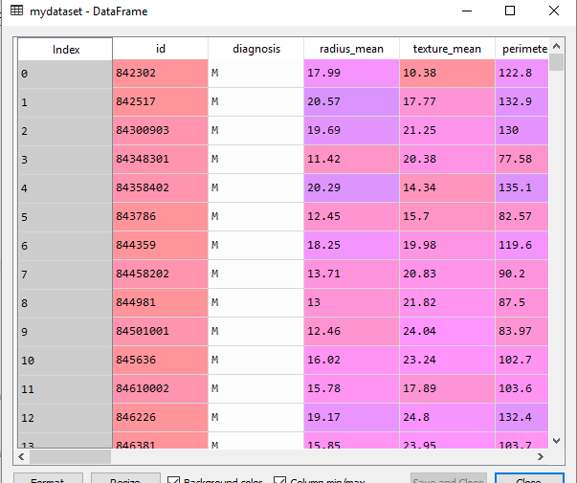

(FIG 11: DATASET LOAD)

1. SHAPE OF THE DATSET



(FIG 12: SHAPE OF DATASET)

1. HEADER PART OF DATASET

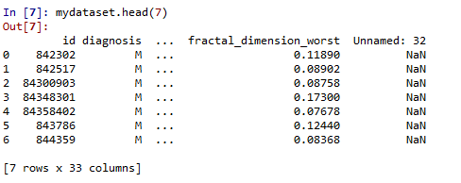

(FIG 13: HEAD SECTION)

1. FINDING A NULL VALUES

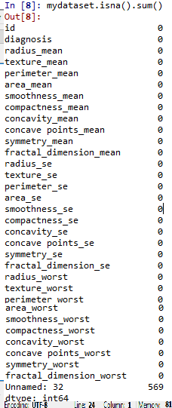

(FIG 14: PREPROCESSING)

1. DROP THE COLUMN WITH ALL MISSING VALUES



(FIG 15: DROP WITH NULL VALUES)

1. DESCRIBING DATASET

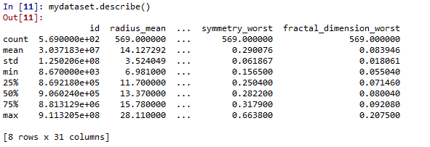

(FIG 16: DESCRIBE)

1. COUNT OF THE DIAGNOSIS

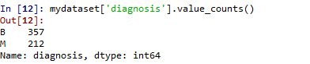

(FIG 17: COUNT OF MALIGANT AND BENGIN)

1. A HISTOGRAM IS A PLOT THAT LETS YOU DISCOVER, AND SHOW, THE UNDERLYING FREQUENCY DISTRIBUTION

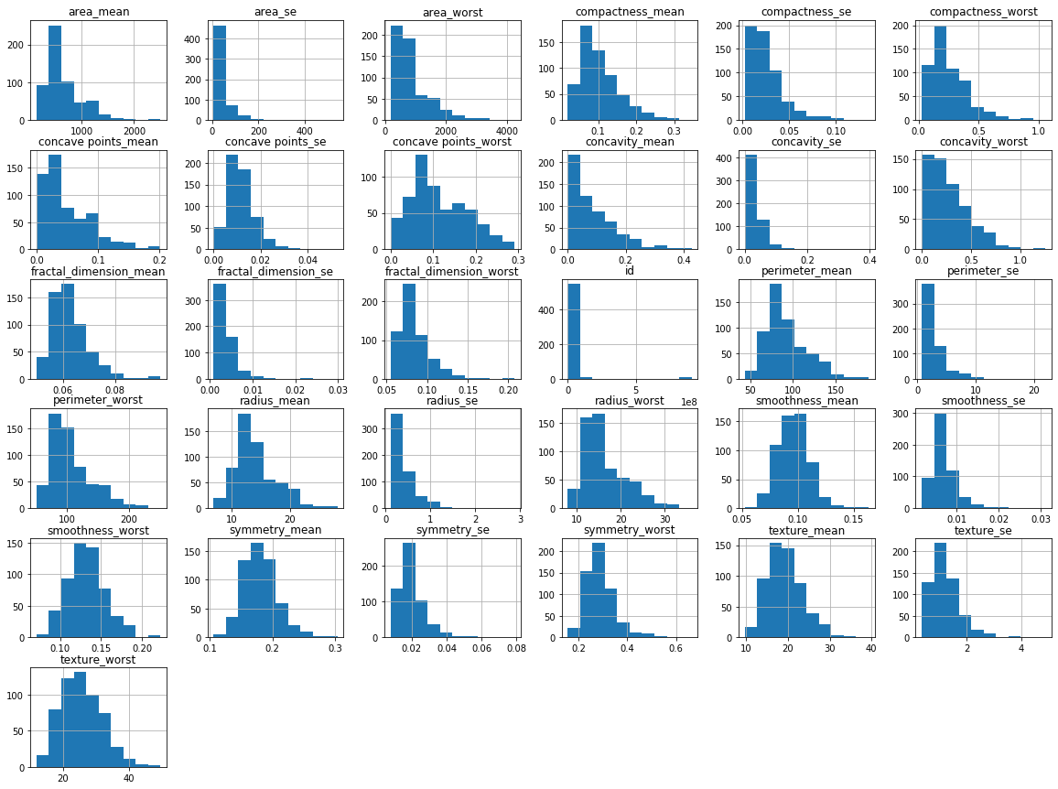

(FIG 18: #A histogram is a plot that lets you discover, and show, the underlying frequency distribution)

1. VISUALIZE THE COUNT

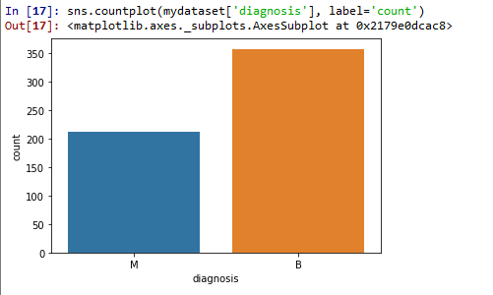

(FIG 19: VISUALIZE THE COUNT)

1. LOOK AT THE (DTYPE) DATA TYPES TO SEE WHICH COLUMNS NEED TO BE ENCODED

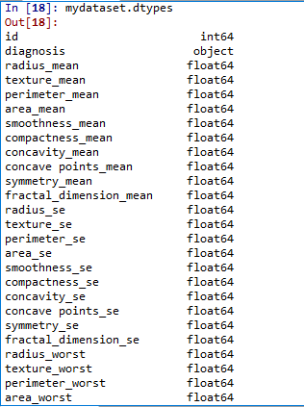

(FIG 20: DATATYPES FOR ENCODING)

1. ENCODE THE CATEGORICAL DATA VALUES

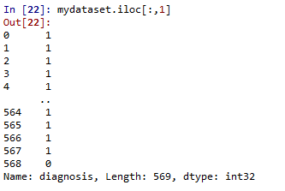

(FIG 21: ENCODE)

1. CREATE APAIR PLOT

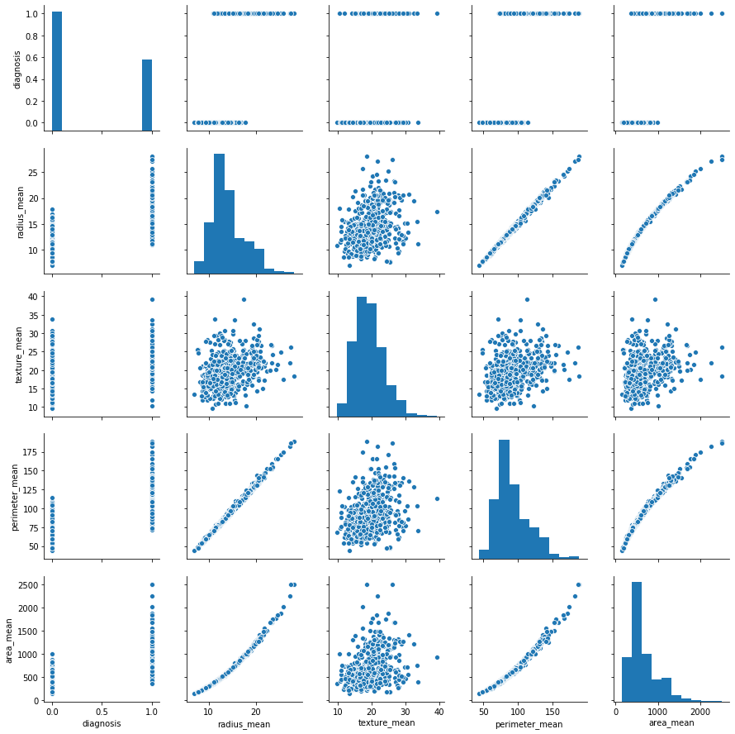

(FIG 22: A PAIRPLOT)

1. CREATE APAIR PLOT WITH HUE

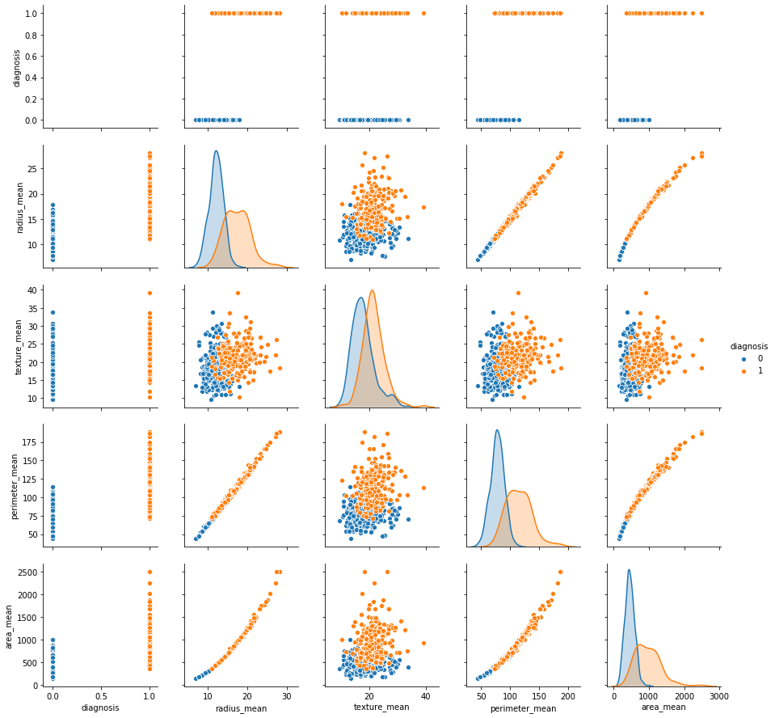

(FIG 23: PAIRPLOT WITH HUE)

1. NEW DATA’S HEADER PART

#print the first 5 rows of the new data

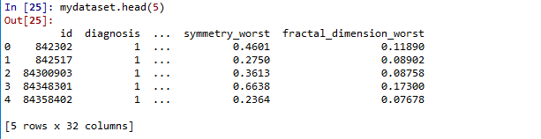

(FIG 24: HEADER)

1. THE CORRELATION OF THE COLUMNS

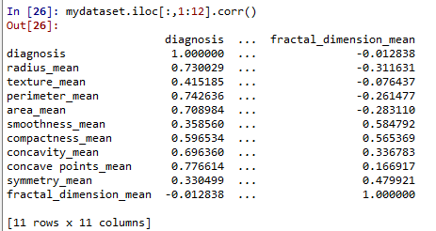

(FIG 25: CO-RELATION)

1. VISUALIZATION OF CO-RELATION

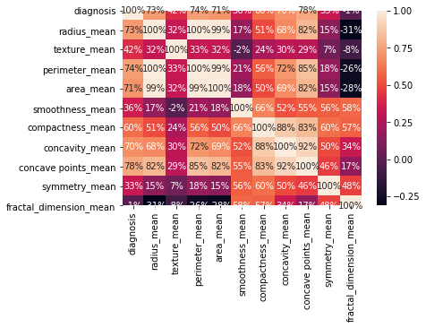

(FIG 26: VISUALIZATION OF CO-RELATION)

1. BOX PLOT TO CHECK OUTLIER IN EACH CATEGORY

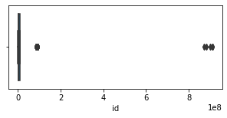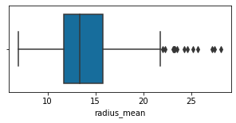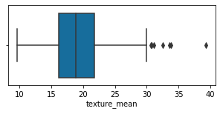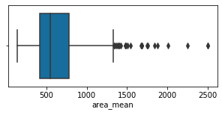

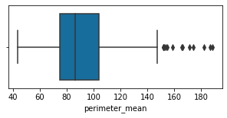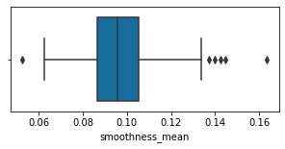

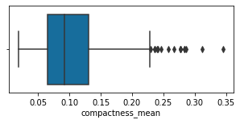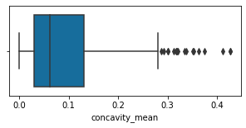

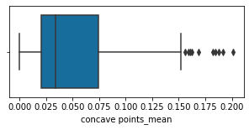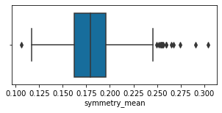

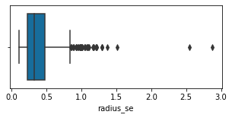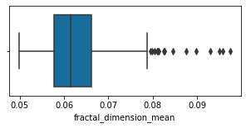

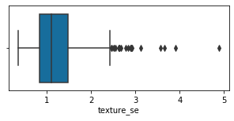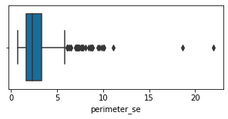

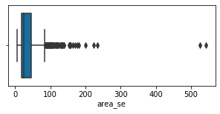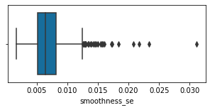

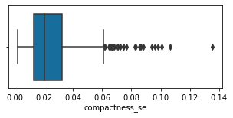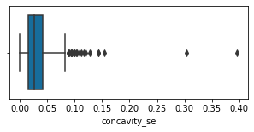

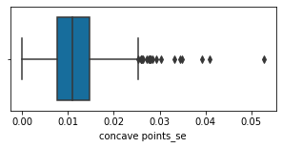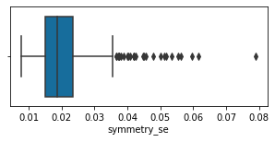

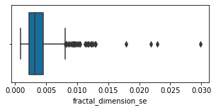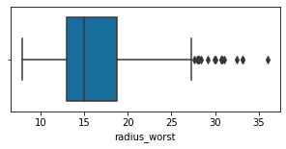

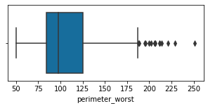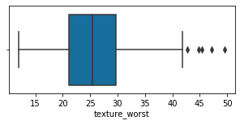

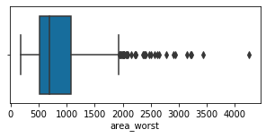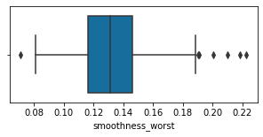

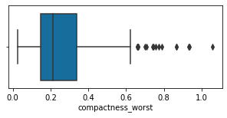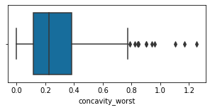

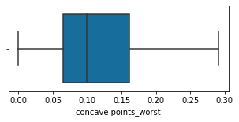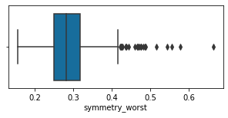

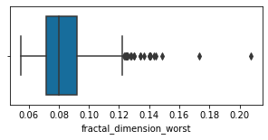(FIG 27: BOXPLOT)

1. split the data set into independent (X) and dependent (y) data sets

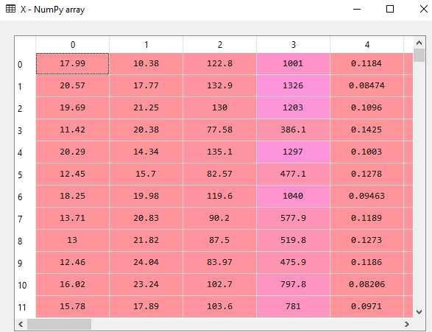

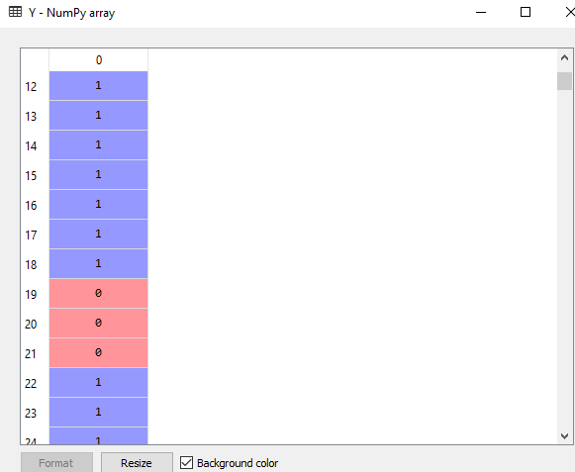

(FIG 28: DATASET OF X-SPLIT AND Y SPLIT)

1. X-TEST AND Y-TEST:

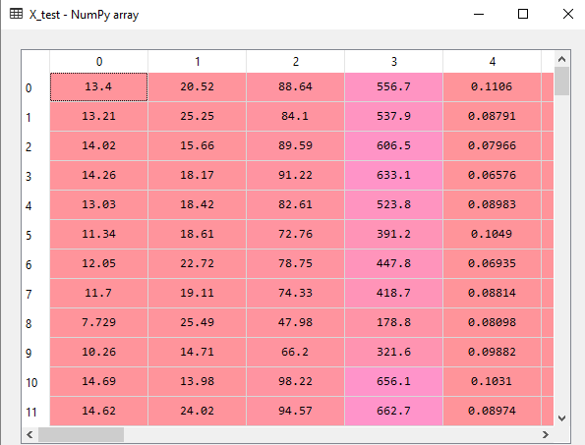

(FIG 29: 75% TRAIN AND 25% TEST)

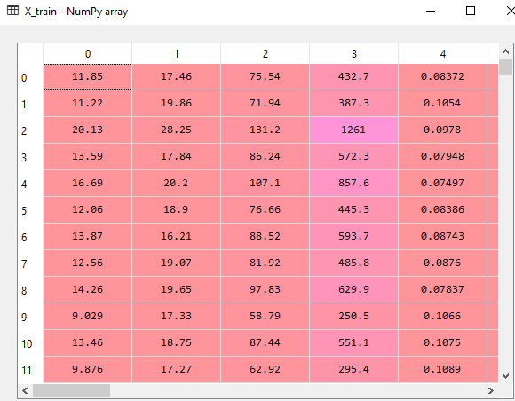

(FIG 30: X-TRAIN)

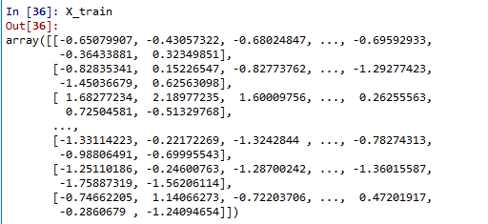

(FIG 31: X-TRAIN SCALE)

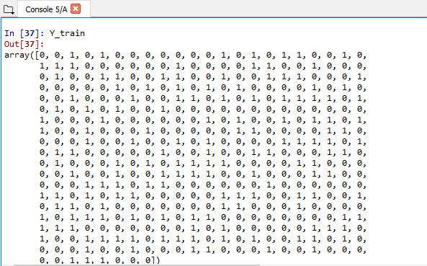

(FI 32: Y-TRAIN)

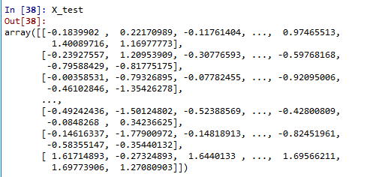

(FIG 33: X TEST)

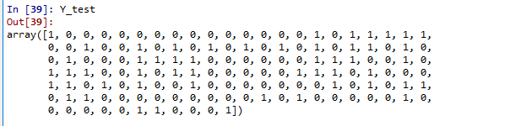

(FIG 34: Y TEST)

1. ACCURACY LEVELOF LOGISTIC REGRESSION:

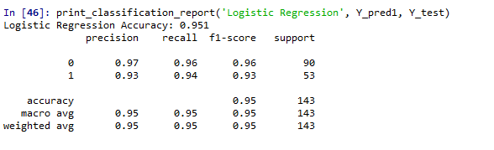

(FIG 35: ACCURACY LEVEL OF LR)

1. CONFUSION MATRIX OF LOGISTIC REGRESSION:

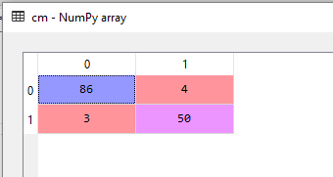(FIG 36 CM)

1. PLOT OF LOGISTIC REGRESSION:

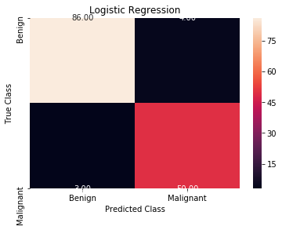

(FIG 37: PLOT OF LR)

1. FINAL PREDICTION OF LR IS: 95.1

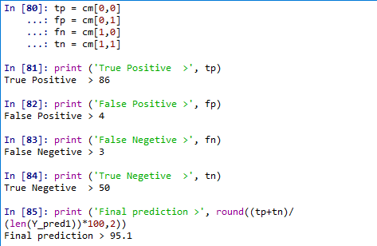

(FIG 38: FINAL PREDICTION)

1. ROC AND AUC VALUE OF LOGISTIC REGRESSION:

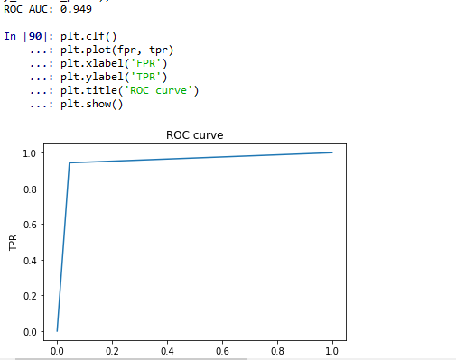

(FIG 39: ROC AND AUC OF LR)

1. ACCURACY LEVEL OF RANDOM FOREST:

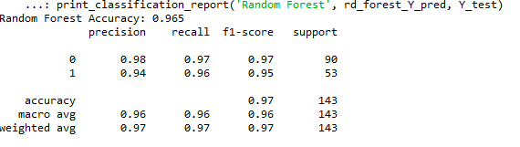

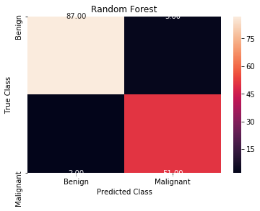

(FIG 40: ACCURACY LEVEL AND PLOT OF RF)

1. CONFUSION MATIX AND FINAL PREDICTION OF RF(96.5)

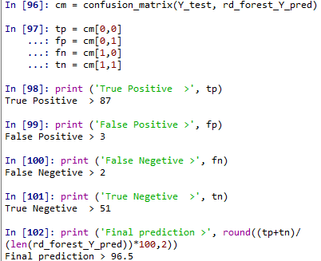

(FIG 41: FINAL PREDICTION OF RF)

1. ROC CURVE AND AUC FOR RF:

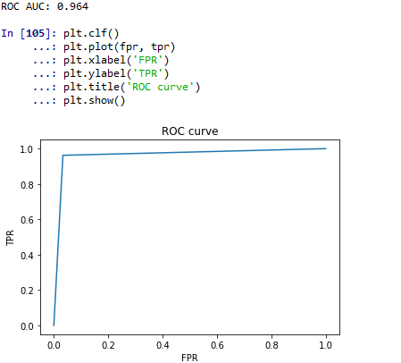

(FIG 42: ROC CURVE AND AUC SCORE)

1. ACCURACY LEVEL OF GAUSSION NAVIE BAYES:

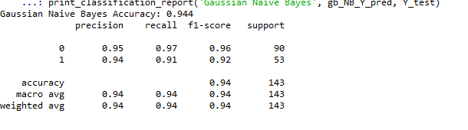

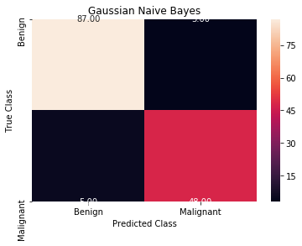

(FIG 43: GAUSSION NAVIE BAYES ACCURACY & PLOT OF NB)

1. CONFUSION MATRIX AND FINAL PREDICTION OF GNB

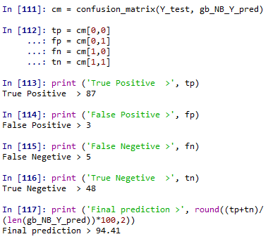

(FIG 44: FINAL PREDICTION OF GNB)

1. ROC CURVE FOR GNB AND AUC SCORE(0.936)

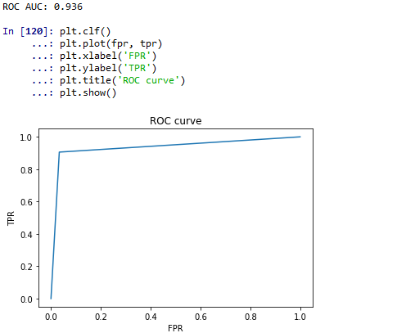

(FIG 45: ROC AND AUC SCORE OF GNB)

1. ACCURACY OF DECISION TREE

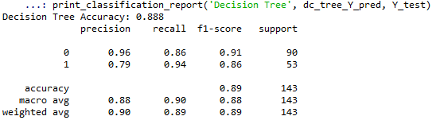

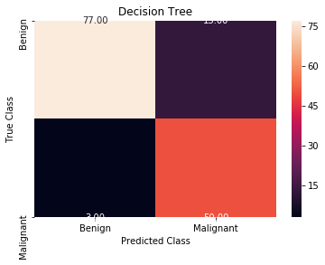

(fig 46: decision tree ACCURACY AND PLOT)

1. CONFUSION MATRIX AND FINAL PREDICTION OG DECISION TREE(93.71)

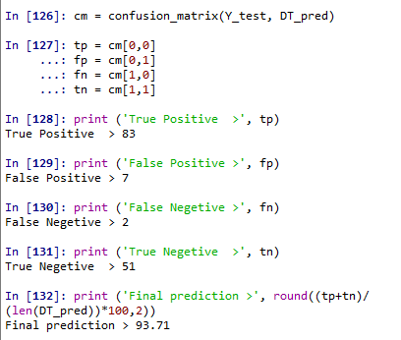

(FIG 47: FINAL PREDICTION OF DECISION TREE)

1. ROC AND AUC SCORE FOR DT:

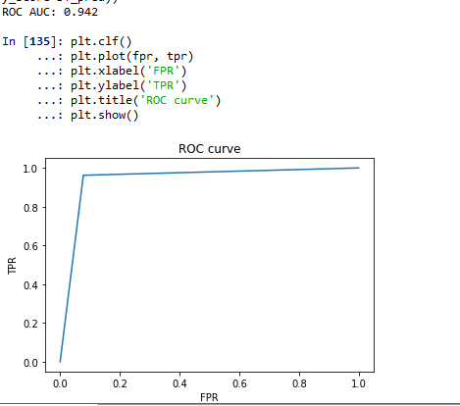

(FIG 48: ROC AND AUC SCORE FOR DT)

1. VARIABLE EXPLORES:

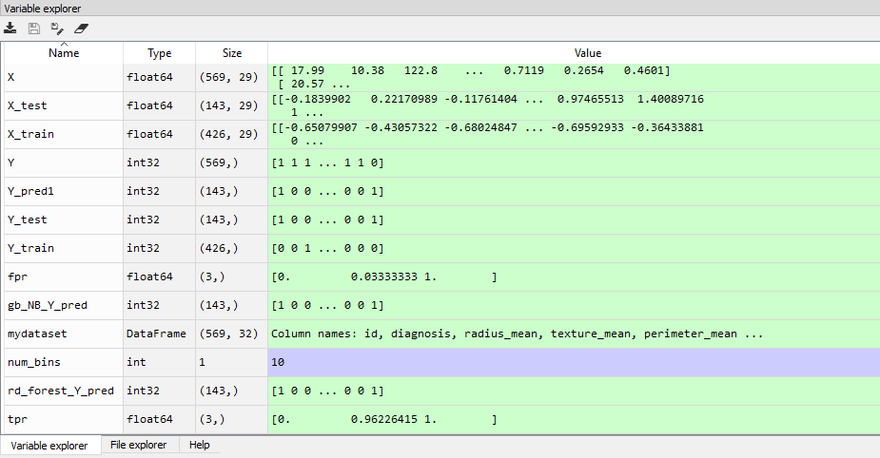

(FIG 49: VARIABLE EXPLORER)

1. GRAPH OF ACCURACY SCORE:

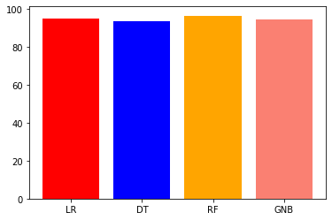

(FIG 50: GRAPH OF ACCURACY SCORE)

1. GRAPH OF ROC_AUC SCORE:

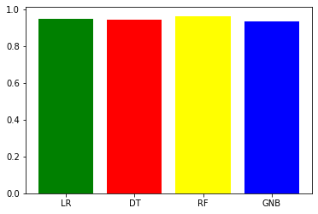

(FIG 51: GRAPH OF ROC_AUC_ SCORE